By Guest Blogger Gina Tepper
www.ginatepper.com
www.giftdecorating.com
Vintage Wedding Gift Designs
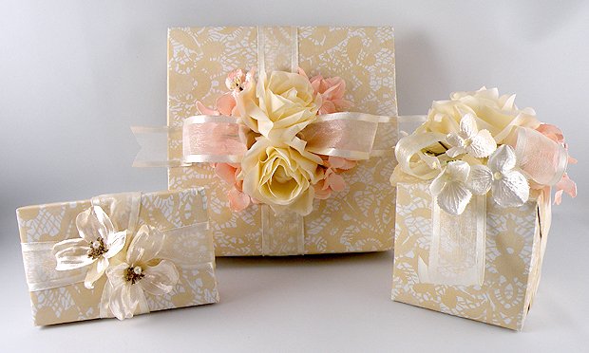
A timeless elegance is created in the classic style of antique wedding gowns and floral arrangements. This vintage look was created with the beautiful Lace Cutworks gift wrap and light and airy cream Satin Sheer Ribbon. Silk flowers in matching tones are added to accent this stunning gift decoration.

Materials Used for the Vintage Wedding Gift Designs
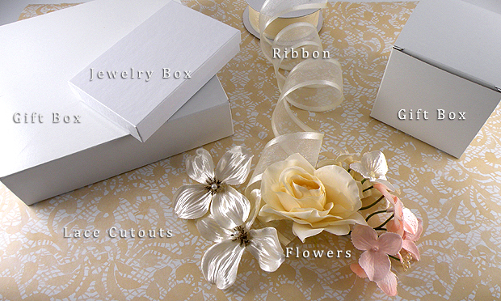
- Lace Cutouts Gift Wrap
- 1-1/2 “ Cream Satin Wired Satin Edge Organza Ribbon
- Large cream fabric roses and satin wedding flowers, stems removed
- Small cream flowers
- Small powder pink flowers
- Craft glue (for securing ribbon)
- Glue gun (for attaching flowers)
- Double-Sided Tape
- White Jewelry Boxes
- Recycled White Gift Boxes
- Recycled White Gloss Gift Boxes

Gift Box Design
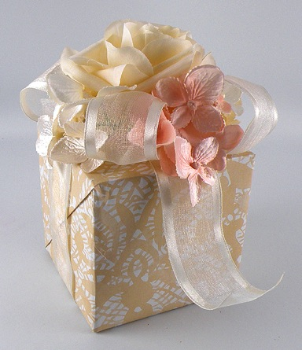
The Recycled White Gift Boxes are a nice size to decorate — they look like a wedding bouquet gift wrap.
Instructions
- Wrap a box in Lace Cutouts Gift Wrap.
- Cut a piece of Organza Ribbon long enough to wrap around the entire box 4 times.

Note: Ribbon measurements are approximate. The lengths may have to be adjusted slightly based on the size of the box used.

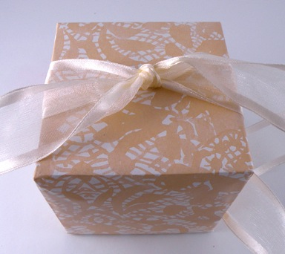

- Centering the ribbon on the bottom of the box, bring the both sides of the ribbon to the center top of the box and tie in a knot.

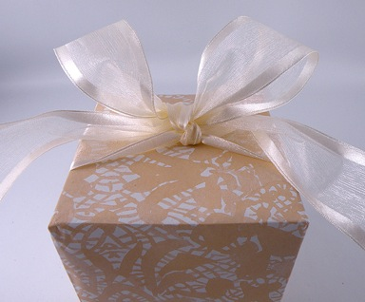

- Tie a bow on one side of the box the same way shoelaces are tied. Adjust the loops so they are big and fluffy and even with each other.

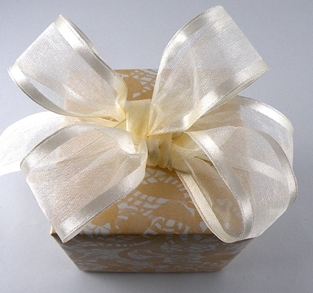

- With the remaining length of the ends, tie a bow on the opposite side of the box to create a 4-loop bow. Adjust all loops so they are even with each other and have an open form.
Note: Don’t worry if the center of the bow looks a little off center, it will be covered by the flowers.

- Trim the ends to matching lengths, cutting them into a V and bending them to form a nice shape. Keep the tails long so they will flow over the side of the box.

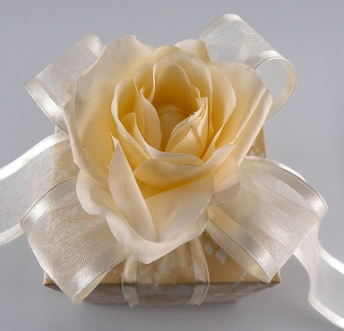

- Attach the large fabric flower onto the center of the bow with a glue gun.

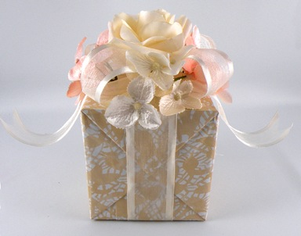

- Using the glue gun, apply glue to the end of a bunch of small flowers and slide under the large flower on one side of the box. Repeat with small bunches of small flowers on all sides of the gift. You can alternate with cream and dusty rose flowers.

Jewelry Box Design
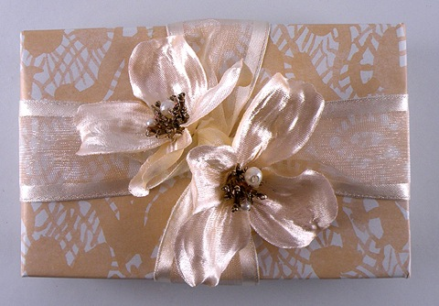
The White Jewelry Boxes are perfect for holding small gifts or gift cards.
- Wrap a box in Lace Cutouts Gift Wrap.
- Cut a piece of Organza Ribbon long enough to wrap around the entire box 2 times.

Note: Ribbon measurements are approximate. The lengths may have to be adjusted slightly based on the size of the box used.

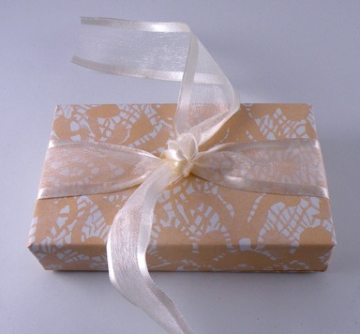

- Centering the ribbon on the bottom of the box, bring the both sides of the ribbon to the center top of the box and tie in a knot.
- Tie the ends again into a loose knot and bring the ribbon down on opposite sides of the box.

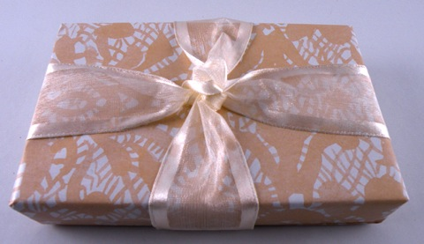
- Glue the overlapping the ends on the bottom of the box with the craft glue.

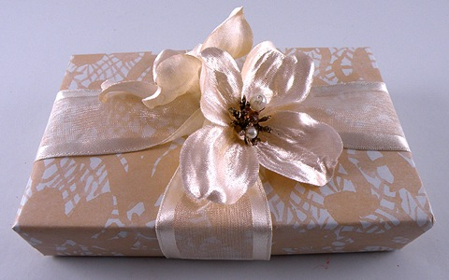

- Using a glue gun, apply glue to the bottom of a flower and attach it to the box near the knot, between the two strips of the ribbon. Repeat on the opposite side of the knot.

Large Box Gift Design
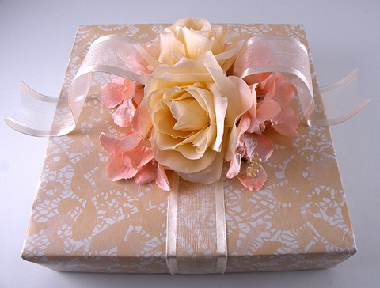
The Recycled White Gloss Gift Boxes come in various sizes and can be used to wrap larger items.
- Wrap a box in Lace Cutouts Gift Wrap.
- Cut a piece of Organza Ribbon long enough to wrap around the entire box 2 times.

Note: Ribbon measurements are approximate. The lengths may have to be adjusted slightly based on the size of the box used.

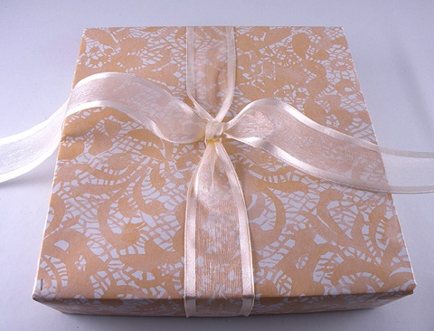
- Centering the ribbon on the bottom of the box, bring the both sides of the ribbon to the center top of the box and tie in a knot.

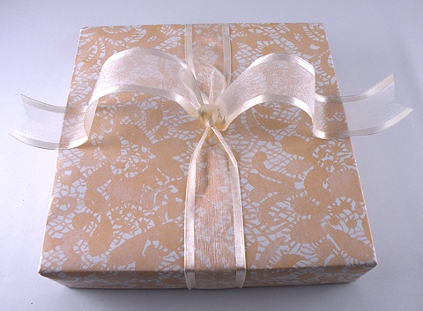

- Trim the ends to matching lengths, cutting them into a V and bending them to form a nice shape.

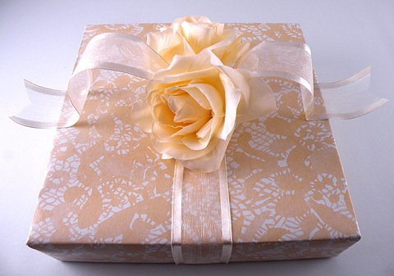

- Using a glue gun, apply glue to the bottom of one of the large flowers and attach to the box on top of the ribbon, at a slight angle near the knot, on the side without the tails. Repeat on the opposite side of the box with the remaining large flower.

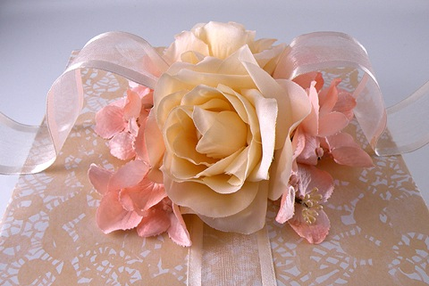

- Apply glue to the end of a bunch of small flowers and slide under one of the large flowers between the flower and the ribbon tails. Repeat with the other bunches of small flowers on all sides of the gift.

Note: You can add small amounts of craft glue on the ribbon tails to attach them to the box so they will hold their shape.

